JICA Program GENERAL INFORMATION

Knowledge Co-Creation Program (Group and Region Focus)

Tourism Development

Policies

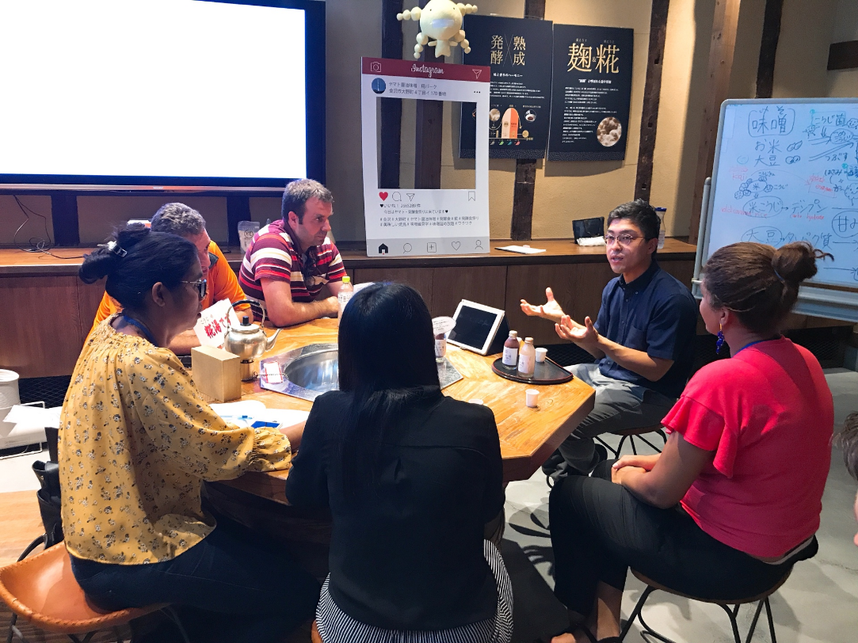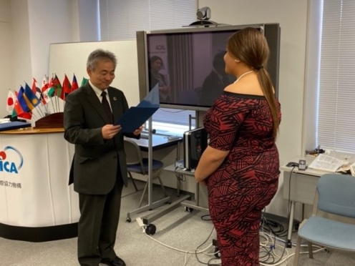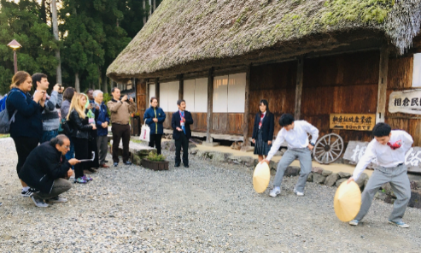

|  |
| --- |
|  |

Course Number: 202107853J001

Program Period:

On-demand: October 1 – October 31, 2022

Interactive: November 1 – November 30, 2022

NOTE: Adobe Acrobat Leader DC and Google Chrome are recommended as PDF viewer. JAWS and NVDA are recommended as screen reader.

NOTE: If there are any difficulties in reading this document, please contact JICA Office in your country or JICA Center in Japan.

NOTE: Depending on the circumstances, some or all of the program periods may be changed or cancelled after the application has been accepted.

課題別研修「観光開発政策」／JICA北陸

How do we  
upgrade

the tourism industry

in your country?

Gain insight

and

specific measures

to develop the tourism policy

in your country

more practical, more interactive,

more inspirational

from the experiences of Japan.

# **Outline**

|  |  |  |
| --- | --- | --- |
| **Image photos** | This program is designed for;  (1)Ministries and government offices concerning the tourism development policy, or its related organization, or,  (2)Local government offices or public agencies in charge of the tourism development policy.  The sessions will be held online and will include self-study and discussion with web conference.  All sessions are carried out in English.  The period of the program is from October 1 to Octboer 31,2022 (on-demand) and November 1 to November 30, 2022(interactive).  Program Capacity:  11 participants | **Image photos** |

# **JICA Knowledge Co-Creation Program (KCCP)**

The Japanese Cabinet released the Development Cooperation Charter in February 2015, stated that “In its development cooperation, Japan has maintained the spirit of jointly creating things that suit partner countries while respecting ownership, intentions and intrinsic characteristics of the country concerned based on a field oriented approach through dialogue and collaboration. It has also maintained the approach of building reciprocal relationships with developing countries in which both sides learn from each other and grow and develop together.” We believe that this ‘Knowledge Co- Creation Program’ will serve as a foundation of mutual learning process.

# **Table of Contents**

For What?

(Background, Objectives)  6

To Whom?

**(Job Areas and Organizations, Targeted Countries) 6**

When?

**(Program Period, Time zones) 7**

Where?

(Place Where the Program Take Place)  7

How?

(How to Learn, Language, Commitment to the SDGs) 8

(Program Structure, Program Schedule) 8-11

(Management Members) 12-13

Eligibility and Procedures

(Expectations to the Applying Organizations, Nominee Qualifications) ...................... 14-16

(Required Documents for Application) 16

(Procedures for Application and Selection) 16-17

[(Additional Document(s) to Be Submitted by Accepted Candidates) 17](#_Additional_Document(s)_to)

(Conditions for Participation) 18

Administrative Arrangements

**(Organizer (JICA Center in Japan), Implementing Partner, Pre-Program Orientation)** 18-19

Annex

(Questionnaire) 20-21

For Your Reference

(JICA and Capacity Development, Japanese Development Experience)  22-23

Correspondence

(For Enquiries and Further Information) 24

# **For What?**

―――――――――――――――――――

## **Background**

It is widely recognized that tourism industry contributes to the development of various areas including job opportunities and income generation. UNWTO has been implementing the international cooperation activities such as human resource development for the developing countries after its establishment in 2003. UNTWO claims the necessity of officers to develop policies for tourism development more efficiently and effectively.

―――――――――――――――――――

## **Objectives**

This Program aims that the participants will;

- obtain the necessary skills for tourism policies; information gathering, analysis, planning, implementation and monitoring,

- reconsider the appropriate tourism policy that match the current situation of their country.

# **To Whom?**

―――――――――――――――――――

## **Job Areas and 　Organizations**

This program is designed for;

(1) Ministries and government offices concerning the tourism development policy, or its related organization, or,

(2) Local government offices or public agencies in charge of the tourism development policy.

The applying organization with the best intention to utilize the opportunity of this program will be highly valued in the selection.

―――――――――――――――――――

## **Targeted Countries**

|  |
| --- |
| Cambodia, Egypt, Iran, Iraq, Laos, Pakistan, Tajikistan, Uzbekistan  Participants who have successfully completed the program will be awarded a certificate by JICA. |

# **When?**

―――――――――――――――――――

## **Program Period**

|  |
| --- |
| UD logo of Online |
| [Part1 : On-demand]  From October 1, 2022  to October 31, 2022  [Part2 : Interactive]  From November 1, 2022  to November 30, 2022 | |

―――――――――――――――――――

## **Interactive Session Time**

|  |
| --- |
| During the part 2 period, all participants will be connected via Zoom in following time zones.  • Japan: 06PM and 09PM • Laos: 04PM and 07PM • Cambodia: 04PM and 07PM • Uzbekistan: 02PM and 05PM • Tajikistan: 02PM and 05PM • Pakistan: 02PM and 05PM • Iran: 01:30PM and 03:30PM • Iraq: 00PM and 03PM • Egypt: 11AM and 02PM |

# **Where?**

This Program is carried out totally online, organized by JICA Hokuriku Center. You will receive essential reading materials for your self-study at your office or home. As the online homeroom and Q&A sessions are held to assist your learning process, you are required to have a certain IT environment. For detail, see page 15.

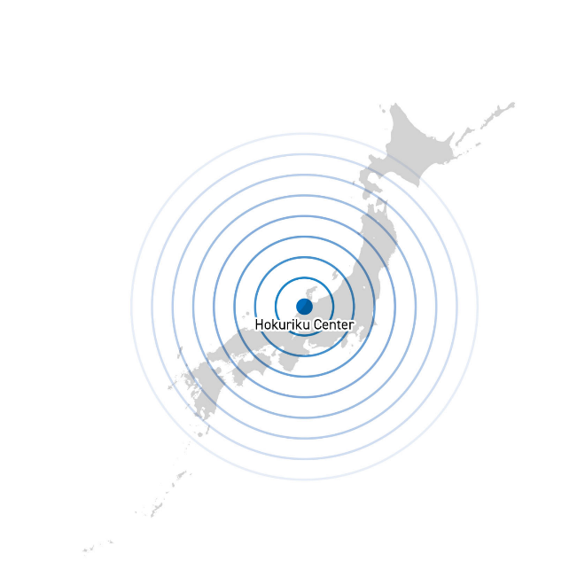

# **How?**

――――――――――――――――――――――――――――――――――――――――

How to Learn

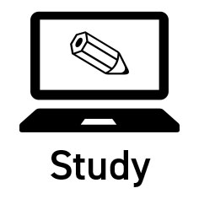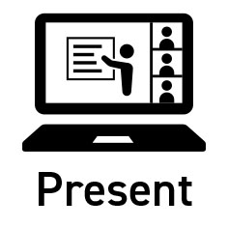

• Online Self-Study

• Online Interactive

Q&A Session

• Lectures

• Workshops

• Discussions

• Presentations

|  |
| --- |
|  |

――――――――――――――――――――――――――――――――――――――――

Language

English

――――――――――――――――――――――――――――――――――――――――

Commitment to the SDGs

|  |
| --- |
| upload.wikimedia.org/wikipedia/commons/c/cf/Sus...Main logo of SDGs (Sustainable Development Goals) |

―――――――――――――――――――――――――――――――――――――――

Program Structure

Part 1:

On-demand Self-study Period

Prior to the interactive sessions, participants take in total 18 on-demand video lectures (length of each video is about 30 minutes) to obtain the knowledge or confirm their understandings on the certain issues around the tourism policy making during October 1-31.

Part 2:

Interactive Session Period

Based on the knowledge pre-acquired during part 1, participants have workshops, discussion, presentations and Q&A sessions interactively during November 1-30. The detailed schedule of this term as shown below.

Program Schedule







Management Members

|  |  |
| --- | --- |
| **Instructors (more to be confirmed)** Program Leader  Dr. SHIKIDA Asami  Professor  Japan Advanced Institute of Science and Technology(JAIST)  School of Knowledge Science, Center for Reskill & Recurrent Education  His specialties are Local studies, Tourism studies and Social-ecological systems. In collaboration with the private sector, NGOs and local community, he has played an important role in rural revitalization and tourism development. |  |
| Vice Program Leader  Mr. AKAHO Yuma  Research Fellow  Japan Advanced Institute of Science and Technology(JAIST)  Center for Reskill & Recurrent Education  His field of study in detail is socio-ecological cyclical process for the effective prevension of ecosystem and sustainable tourism especially for mountainous national park area. |  |
| Implementing Partners  Ms. HASE Kuniki  Research Fellow  Japan Advanced Institute of Science and Technology(JAIST)  She has been in charge of curriculum operation; supporting the learning/practical progress of the participants in cooperation with coordinators. |  |
| Mr. ARAIE Teppei  Research Fellow  Research Institute of Regional and Urban Planning  He has been in charge of curriculum operation; supporting the learning/practical progress of the participants in cooperation with coordinators. |  |

|  |  |
| --- | --- |
| Coordinator (to be decided)  Coordinator of KCCP  S/he has extensive experience in coordinating the Knowledge Co-Creation Program (KCCP). |  |
| Program Officer  Ms. SHIRAKI Haruko  Japan International Cooperation Agency (JICA)  Private Sector Development Group,  Economic Development Department |  |
| Director  Mr. IMAI Tatsuya  Japan International Cooperation Agency (JICA)  Hokuriku Center |  |
| Program Officer  Ms. YAGO Naoko  Japan International Cooperation Agency (JICA)  Hokuriku Center |  |
| Staff  Ms. SAKAMOTO Megumi  Japan International Cooperation Agency (JICA)  Hokuriku Center |  |

# **Eligibility and Procedures**

――――――――――――――――――――――――――――――――――――――――

**1. Expectations to the Applying Organizations**

(1) This Program is designed primarily for organizations that intend to address specific issues or problems identified in their operations. Applying organizations are expected to use the program for those specific purposes.

(2) This Program is enriched with contents and facilitation schemes specially developed in collaboration with relevant prominent organizations in Japan. These special features enable the Program to meet specific requirements of applying organizations and effectively facilitate them toward solutions for the issues and problems.

(3) In this connection, applying organizations are expected to nominate the most qualified candidates to address the said issues or problems, carefully referring to the qualifications described in section 2 below.

(4) Applying organizations are also expected to be prepared to make use of knowledge acquired by the nominees for the said purpose.

―――――――――――――――――――――――――――――――――――――――

**2. Nominee Qualifications**

Applying organizations are expected to select nominees who meet the following qualifications.

**(1) Essential Qualifications**

* 1. Attendance: the Program participants are required to attend Online Q&A Sessions, Lectures, workshops, discussions, presentations at designated time on Attachment.
  2. Position: Officers from; (a) Ministries and government offices concerning the tourism development policy, or its related organization, or (b) local government offices or public agencies in charge of the tourism development policy.
  3. Officers in charge of planning the tourism development policy.
  4. At least 3 years' working experience in the relevant field
  5. Educational Background: be a graduate of university or equivalent
  6. Language Proficiency: a competent command of spoken and written English proficiency - active participation in discussions, which requires high competence in English. Please attach an official certificate for English ability such as TOEFL, TOEIC etc, if possible.
  7. Technical Requirements：

1. Technology Proficiency
   * Basic computer skills such as, sending/receiving email with attachments, and using a web browser.
   * Online program is delivered using the following services, Web Conferences (Zoom), Cloud Storage (GIGAPOD), YouTube and other online platforms. Online tutorial and support by JICA will be limited. The ability to be self-directed in learning new technology skills are required.
2. Internet Connection

* High Speed Broadband Connection (at least 2Mbps).

* Internet access charge incurred for this Program shall be borne by your organization.

1. Hardware (Minimum Requirement)

* Regular access to a computer, either from your home or from your office.
* Operating System: Windows or Mac OS (Updated version is preferred).
* Processor: Intel Core 2 Duo or higher; 2GHz or higher
* Memory: 4GB of RAM or higher
* Hard Drive Space: 5GB free disk space
* Browser: Google Chrome is preferred browser. (Edge, Firefox, Safari can be used)
* Others: Webcam Microphone, and Audio output Device (Speaker or Headset)

1. Software (which may be required)

* Zoom Client for Meeting (https://zoom.us/download)

* In case you are using your office computer and use of Zoom is not authorized by your IT administrator, please notify JICA at the time of application.

* 1. Health: must be in good health to participate in the program.

**(2) Recommended Qualifications**

* 1. Age: between the ages of twenty-five (25) and fifty (50) years
  2. Gender Consideration: JICA promotes gender equality. Women are encouraged to apply for the program.
  3. Other: It is preferable that the participants have some relationship with other JICA activities.
  4. Difficulties/Disabilities: The participation of person with difficulties/disabilities is welcomed. Please write your situation in the Questionnaire on medical status restriction of the Application form. (Japan ratified the Convention on the Rights of Persons with Disabilities in January 2014 and JICA has observed it.)

――――――――――――――――――――――――――――――――――――――――

## **3. Required Documents for Application**

(1) **Application Form:** The Application Form is available at the JICA overseas office (or the Embassy of Japan)

* If you have any difficulties/disabilities which require assistance, please specify necessary assistances in the QUESTIONNAIRE ON MEDICAL STATUS RESTRICTION (1-(c)) of the application form.

(2) **Photocopy of Passport or Official ID:** You should submit it with the application form if you possess your passport or official ID. If not, you are requested to submit its photocopy as soon as you obtain it.

*The following information should be included in the photocopy:

Name, Date of Birth, Nationality, Sex, Passport Number and Expiry Date

(3) **English Score Sheet:** to be submitted with the application form, if the nominees have any official English examination scores. (e.g., TOEFL, TOEIC, IELTS)

(4) **Questionnaire:** to be submitted with the application form. Fill in Annex I of this General Information.

――――――――――――――――――――――――――――――――――――――――

## **4. Procedures for Application and Selection**

**(1) Submission of the Application Documents**

Closing date for applications: **Please confirm the local deadline with the JICA overseas office (or the Embassy of Japan)**.

（All required material must arrive at JICA Center in Japan by September 8, 2022）

**(2) Selection**

Primary screening is conducted at the JICA overseas office (or the embassy of Japan) after receiving official documents from your government. JICA Center will consult with concerned organizations in Japan in the process of final selection. Applying organizations with the best intentions to utilize the opportunity will be highly valued.

The Government of Japan will examine applicants who belong to the military or other military-related organizations and/or who are enlisted in the military, taking into consideration of their duties, positions in the organization and other relevant information in a comprehensive manner to be consistent with the Development Cooperation Charter of Japan.

**(3) Notice of Acceptance**

The JICA overseas office (or the Embassy of Japan) will notify the results **not later than September 30, 2022.**

――――――――――――――――――――――――――――――――――――――――

## **5. Additional Document(s) to Be Submitted by Accepted Candidates**

**Problem Analysis Presentation** -- to be submitted by October 31, 2022

Accepted candidates are required to prepare the presentation slides for “Problem Analysis Presentation”, which describes the current situation and facing problems of your affiliation. (More detailed information is to be followed upon Acceptance Notice). It should be submitted to JICA, preferably via JICA-VAN, an LMS(On-line Lerning Management System).

**Action Plan** –- to be submitted during the Program.

Participants are required to prepare Action Plan and to make presentation at the last 3 days of the Program. Detailed information is to be announced during the Program.

――――――――――――――――――――――――――――――――――――――――

## **6. Conditions for Participation**

The participants of KCCP are required

* + - * 1. to strictly observe the Program schedule (the Program participants are required to attend Online Q&A Sessions, Lectures, workshops, discussions, presentations at designated time on Attachment),
        2. not to change the program topics, and
        3. not to record or share the online training program without permission of JICA

# **Administrative Arrangements**

――――――――――――――――――――――――――――――――――――――――

## **Organizer (JICA Center in Japan)**

1. **Center**: JICA Hokuriku Center (JICA HOKURIKU)
2. **Program Officer**: Ms. YAGO Naoko ([Yago.Naoko@jica.go.jp](mailto:Yago.Naoko@jica.go.jp))

――――――――――――――――――――――――――――――――――――――――

## **Implementing Partner**

1. **Name:　Japan Advanced Institute of Science and Technology**
2. **URL**: <https://www.jaist.ac.jp/english/>
3. **Remark**: Japan Advanced Institute of Science and Technology is established in 1990 as the first independent national graduate university, to carry out graduate education based on research at the highest level in advanced science and technology. JAIST aims at establishing an ideal model of graduate education for Japan.
4. **Name:　Research Institute of Regional and Urban Planning**
5. **URL**: <https://www.rirup.or.jp/>
6. **Remark**: RIRUP is a think tank established in 1976 to promote regional and urban planning projects and contribute to the local community development.

――――――――――――――――――――――――――――――――――――――――

## **Pre-Program Orientation**

YouTube of “Knowledge Co-Creation Program and Life in Japan” and “Introduction of JICA Center” are viewable from the link below.

Image video of 'Introduction of JICA Center (YouTube)' shows the relevant information.

|  |  |
| --- | --- |
| **Part I: Knowledge Co-Creation Program and Life in Japan** | |
| English ver. | <https://www.youtube.com/watch?v=SLurfKugrEw> |
| French ver. | <https://www.youtube.com/watch?v=v2yU9lSYcTY> |
| Spanish ver. | <https://www.youtube.com/watch?v=m7l-WlQSDjI> |
| Russian ver. | <https://www.youtube.com/watch?v=P7_ujz37AQc> |
| Arabic ver. | <https://www.youtube.com/watch?v=1iBQqdpXQb4> |
| **Part II: Introduction of JICA Centers in Japan** | |
| JICA Hokuriku | <https://www.jica.go.jp/hokuriku/english/office/index.html> |

If the link of these URLs has expired, please access the URL below and search the nessesary information from the key word.

[https://www.youtube.com/user/JICAChannel02](https://jpn01.safelinks.protection.outlook.com/?url=https%3A%2F%2Fwww.youtube.com%2Fuser%2FJICAChannel02&data=04%7C01%7CMatsuyama.Mieko%40jica.go.jp%7Ce0e8d726c1424207703a08d994ff9f8c%7Ceba9fc4255884d318a4e6e1bf79d31c0%7C0%7C0%7C637704647877646627%7CUnknown%7CTWFpbGZsb3d8eyJWIjoiMC4wLjAwMDAiLCJQIjoiV2luMzIiLCJBTiI6Ik1haWwiLCJXVCI6Mn0%3D%7C1000&sdata=CV%2Bt7g0j2CiK8qPjZol1zViIzT%2BWOOyqerxTd%2BUlEMM%3D&reserved=0)

――――――――――――――――――――――――――――――――――――――――

## **Reference**

Website: JICA

English/French/Spanish/Russian

[https://www.jica.go.jp/english/our_work/types_of_assistance/tech/acceptance/training/index.htm](https://www.jica.go.jp/english/our_work/types_of_assistance/tech/acceptance/training/index.html)l

# **Annex I**

Questionnaire

1. **Internet Environment**
   * + 1. Please describe your internet environment at office and home. (Ex. no internet at home, 5GB only at home, etc)

|  |
| --- |
|  |

* + - 1. Please also describe your devices on attending on-line Program. (Ex. PC at office and/or home).

|  |
| --- |
|  |

1. **Support of your supervisor**

JICA expects your supervisor (boss) at your workplace to support you during this Program and to observe your Action Plan presentation at the last day of the Program. **Please secure his/her attendance on the day**.

After the Program, JICA also expects you and your supervisor to implement your Action Plan together with your colleagues. JICA will request you and your supervisor to fill in the monitoring sheet for follow-up of your Action Plan one (1) month after the Program.

**Information of Your Supervisor**

|  |  |  |
| --- | --- | --- |
| Name |  | |
| Position | Organization:  Department/Division:  Position: | |
| Office | Address: | |
| TEL: | Mobile (Cell Phone): |
| FAX: | E-mail: |
| Message to JICA |  | |
| Signature |  | |

# **For Your Reference**

JICA and Capacity Development

Technical cooperation is people-to-people cooperation that supports partner countries in enhancing their comprehensive capacities to address development challenges by their own efforts. Instead of applying Japanese technology per se to partner countries, JICA’s technical cooperation provides solutions that best fit their needs by working with people living there. In the process, consideration is given to factors such as their regional characteristics, historical background, and languages. JICA does not limit its technical cooperation to human resources development; it offers multi-tiered assistance that also involves organizational strengthening, policy formulation, and institution building.

Implementation methods of JICA’s technical cooperation can be divided into two approaches. One is overseas cooperation by dispatching experts and volunteers in various development sectors to partner countries; the other is domestic cooperation by inviting participants from developing countries to Japan. The latter method is the Knowledge Co-Creation Program, formerly called Training Program, and it is one of the core programs carried out in Japan. By inviting officials from partner countries and with cooperation from domestic partners, the Knowledge Co-Creation Program provides technical knowledge and practical solutions for development issues in participating countries.

The Knowledge Co-Creation Program (Group & Region Focus) has long occupied an important place in JICA operations. About 400 pre-organized course cover a wide range of professional fields, ranging from education, health, infrastructure, energy, trade and finance, to agriculture, rural development, gender mainstreaming, and environmental protection. A variety of programs is being customized by the different target organizations to address the specific needs, such as policy-making organizations, service provision organizations, as well as research and academic institutions. Some programs are organized to target a certain group of countries with similar developmental challenges.

Japanese Development Experience

Japan, as the first non-Western nation to become a developed country, built itself into a country that is free, peaceful, prosperous and democratic while preserving its tradition. Japan will serve as one of the best examples for our partner countries to follow in their own development.

From engineering technology to production management methods, most of the know-how that has enabled Japan to become what it is today has emanated from a process of adoption and adaptation, of course, has been accompanied by countless failures and errors behind the success stories.

Through Japan’s progressive adaptation and application of systems, methods and technologies from the West in a way that is suited to its own circumstances, Japan has developed a storehouse of knowledge not found elsewhere from unique systems of organization, administration and personnel management to such social systems as the livelihood improvement approach and governmental organization. It is not easy to apply such experiences to other countries where the circumstances differ, but the experiences can provide ideas and clues useful when devising measures to solve problems.

JICA, therefore, would like to invite as many leaders of partner countries as possible to come and visit us, to mingle with the Japanese people, and witness the advantages as well as the disadvantages of Japanese systems, so that integration of their findings might help them reach their developmental objectives.

|  |
| --- |
| This information pertains to one of the JICA Knowledge Co-Creation Programs (Group & Region Focus) of the Japan International Cooperation Agency (JICA) implemented as part of the Official Development Assistance of the Government of Japan based on bilateral agreement between both Governments. |

# **Correspondence**

For enquiries and further information, please contact the JICA office or Embassy of Japan.

Further, address correspondence to:

JICA Hokuriku Center (JICA Hokuriku)

Address: 4th Floor, Rifare (Office Tower) 1-5-2, Hon-machi, Kanazawa-shi, Ishikawa-ken, 920-0853, Japan

Tel: +81-76-233-5931　　Fax: +8176-233-5959　　Email: [jicahric@jica.go.jp](mailto:jicahric@jica.go.jp)

(“81” is the country code for Japan, and “76” is the local area code)