VI. ANNEX:
Inception Report
Accepted participants are requested to prepare an Inception Report, referring to the following format (Microsoft Power Point) as an example.
  - Detailed explanation for each slide should be written on the NOTE of PPT.
  - The Report should be uploaded to dedicated GIGAPOD of JICA Kansai Center by December 25th, 2020. The URL of the GIGAPOD will be notified with acceptance notice.
  - Online discussion (Zoom) will be organized on January 15th, 2021, in order to discuss the issues of each country.

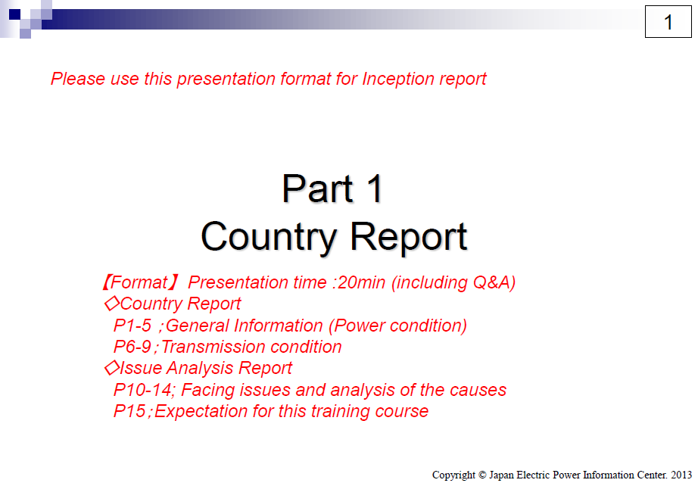

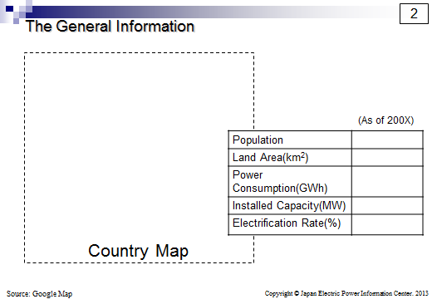

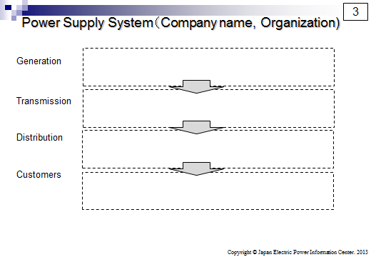

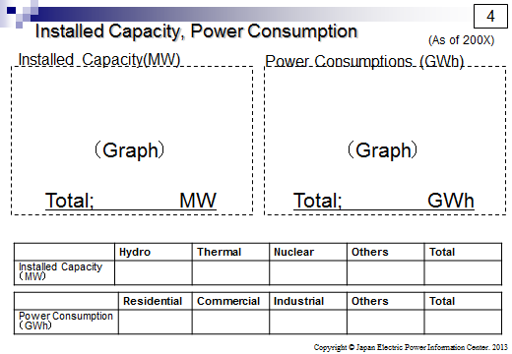

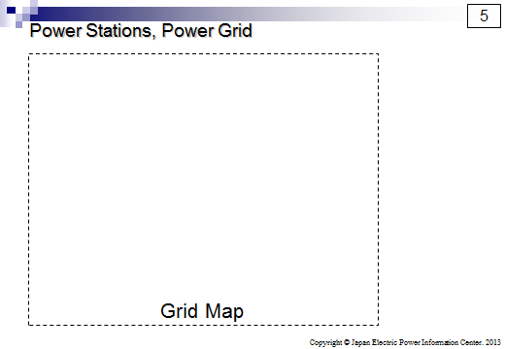

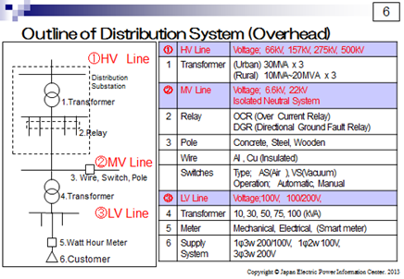

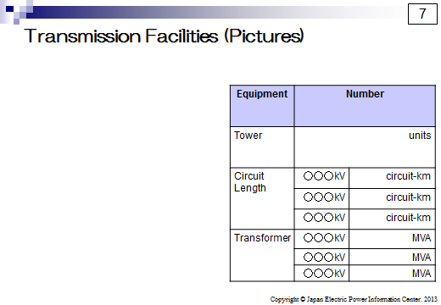

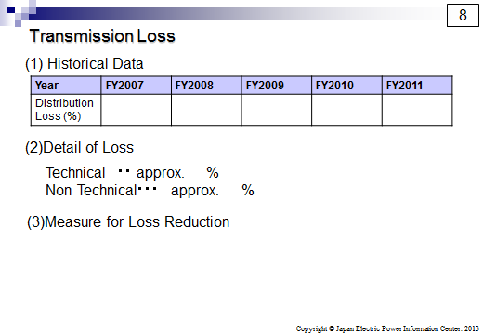

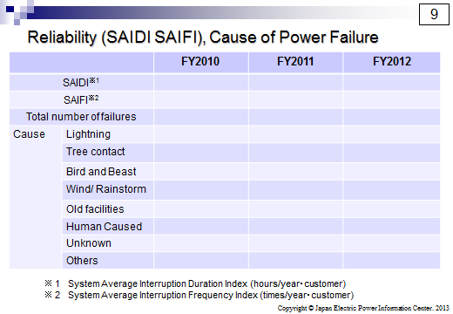

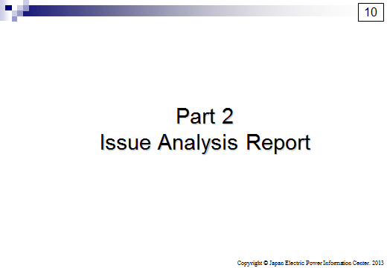

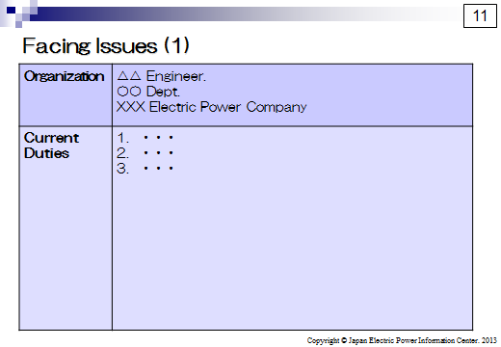

Facing Issue (1)

Issue
Causes | 1.  2.  3.
Countermeasure | 1.  2.

Facing Issue (2)

Issue
Causes | 1.  2.  3.
Countermeasure | 1.  2.

