JICA Knowledge Co-Creation Program
for Long Term Participants

Overview Information

on

Master’s Course

of

“Water Engineering and Utility Management Future Leaders Training Program”

This information pertains to one of the Japan International Cooperation Agency (JICA)’s Knowledge Co-Creation Program (Long-Term). This handout gives information on the overview of the program. This program will be implemented as part of the Official Development Assistance of the Government of Japan based on bilateral agreement between both governments.

- Overview
The JICA Knowledge Co-Creation Program for Long Term Participants on“Water Engineering and Utility Management Future Leaders Training Program” is a new Master Degree Scholarship Program specially provided by the Japan International Cooperation Agency (JICA) in collaboration with Department of Urban Engineering, Graduate School of Engineering, the University of Tokyo, which shall be implemented as part of the Official Development Assistance of the Government of Japan.
This Program provides excellent study and research opportunity for to-be leaders of waterworks to acquire high-level competence comprehensively covering both academic studies and practical knowledge.
The Program consists of a regular graduate program for study and research in the field of engineering at a Japanese university and additional custom-made programs including followings:
- Study and research at the Department of Urban Engineering, Graduate School of Engineering, the University of Tokyo,
- Internship at Japanese water supply utilities,
- Field trips to waterworks and industries with cutting-edge technologies,
- Special lectures on practical topics such as waterworks management, administration, finance, and human resource development,
- Special lectures on Japan’s historical experience to achieve sustainable and quality water supply management, and
- Networking with participants from other Asian countries and Japanese water professionals.

- Objectives
The objective of the Program is capacity development of leaders for the next generation in waterworks. The graduates of the program are expected to lead their waterworks and the water supply sector of their countries to achieve better water supply service and waterworks management.
Therefore the Program aims for the participants to grow and nurture in the following terms;

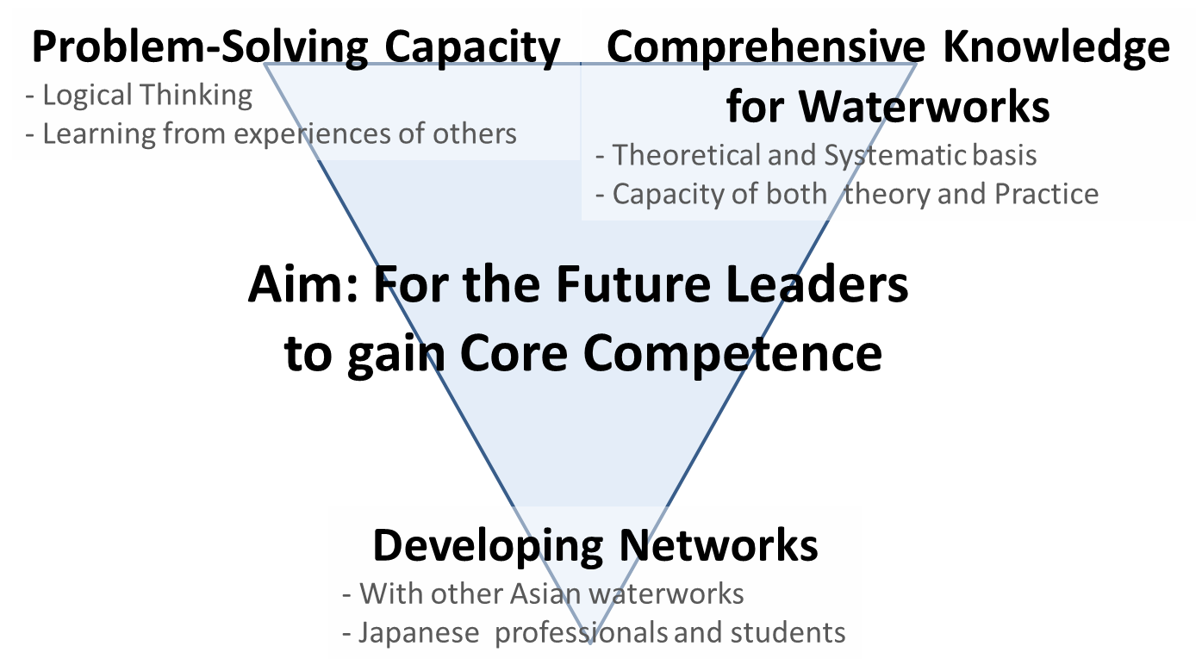
- Problem-Solving Capacity
- Identify, analyze, and solve the issues logically
- Write and present thesis
- Understand, interpret, and apply from experiences of other waterworks
- Comprehensive Knowledge in the field of waterworks
- Acquire the theoretical and systematic basis of water engineering
- Deepen understanding about the utility management
- Enhance comprehensive capacity of both theory and practice
- Developing long-term ties and networks
- Develop network with other participants from Asian waterworks
- Develop networks with Japanese water professionals and students
- Develop long-term partnerships with Japanese waterworks
- Program Outlines
The program consists of three large components.
- Education and research Program (Master’s degree course)
- Acquire theoretical knowledge systematically
- Improve the ability to solve problems through research activities
- Acquire master’s degree in Department of Urban Engineering, Graduate School of Engineering, the University of Tokyo

- Custom made Programs
- Details of Custom made Programs
The custom made Program aims to improve practical abilities, construction of networks, deepen understanding of Japanese water supply field.
- Additional special lectures on utility management and water engineering that are not included in the curriculum of the master course. The subjects are exemplified as follows;
    - Water administration

    - Utility management
    - Organizational management
    - Human resource development
    - Public-Private Partnership (PPP)
    - Public finance accounting
    - Analytical chemistry
    - Water resources engineering
    - Water supply engineering
    - Hydraulic engineering
    - Hydrology

- Lectures on Japan's experiences on water supply development
- Field survey in Japan and/or other country
- Internship at waterworks in Japan
- Field trip to facilities in Japan
- Participation in JICA’s other training courses
- Participation in international conferences
- Participation in international symposium

- Common Programs (Optional)
In addition to the above mentioned programs, JICA will implement the Common Programs for JICA Participants. Some programs will be conducted by JICA Domestic Offices to promote international exchanges and cultural understandings between JICA participants and regional residents.

Also JICA will conduct a program, offering participants opportunities to gain a deep understanding of the Japanese development experience, and to draw lessons and gain insights that will support their development work in their home countries and internationally.
- Number of Participants
5 participants per year
- Duration and Academic Year
Two years in principle
September 2021 --- September 2023
- Language to be used in this Program
English
- Eligibility
- Essential Requirements
Those who meet the following all requirements can apply for this JICA program.
- Current Duties: waterworks engineers
- Experience: at least five (5) years of practical experience in waterworks or governing agencies
- Age: less than forty (40) years old
- Educational Background: have a Bachelor Degree with a 3.0 or higher cumulative GPA (Grade Point Average (maximum 4.0)) * at University
*Those who hold 75% and above GPA are qualified.
- Language: with the linguistic skills required to take courses and receive research guidance in English (Equivalent to above TOEFL iBT 80/ TOEFUL 550/ ILETS 6.0)
- Health: in good health, both physically and mentally, to participate in the Program in Japan
- Nationality: Cambodia, Indonesia, Lao, Myanmar, Nepal, Pakistan, Sri Lanka and Thai
- From Pakistan, staffs from Water and Sanitation Agency (Lahore) and Water and Sanitation Agency (Faisalabad) can apply for this JICA program. Please nominate at least 5 candidates for Pre –selection.
- Recommendable Qualifications
- Those who are expected to play a leading role in waterworks in the future
- Those who have flexible adaptability and receptivity for study and research in a foreign country
- Admissions
Participants must pass University’s usual admission procedures including examinations to enter the program.
- Application Guidelines
Candidate participants have to pass a pre-selection with applicants screening first. Submission of nomination list for pre-selection is required by deadline to be noticed by JICA office. In addition to the information on nomination list, submission of certificates of degree and GPA is required and submission of document that will prove their English skills is strongly recommended.
After pre-selection, candidate participants must apply through both Procedure A and B.
Procedure A is an application process necessary for selection of the candidates, the process will include academic examination by the University of Tokyo, the responsible university of the Program .
Procedure B is an application process necessary for both participant’s Government and the Government of Japan for the Official Development Assistance.
The details of each procedure are written as below.

Procedure A: University Admission Application
- Application Procedures:
Applications should be made through “T-cens”, the online application system of School of Engineering, the University of Tokyo, during the online application period.
URL: https://t-cens.iapply.t.u-tokyo.ac.jp/guidance_information/

- Selection Process:
Preliminary selections is made based on academic performance, research plan, English Proficiency (TOEFL or IELTS, etc.), and letters of recommendation, etc. Applicants who pass the pre-screening will be offered an online interview with a faculty member of the university. Interviews will be arranged on an individual basis.
- Online Application period (tentative)
1st January, 2021 – 31st January, 2021
Note: Participants those who are pre-selected are required to submit all the “Submission documents” no later than January 31st 2021.

- Submission Documents
Participants will be required to submit necessary documents to complete the application. The followings are the major documents to be submitted.
- Academic Application Form for International Graduate Program
- Certificate of Degree/Diploma (Bachelor’s degree)
- Curriculum Vitae
- Research plan
- English Proficiency
- Letters of recommendation
English Proficiency :
Participants are recommended to submit documents which will prove their English skills such as;
- English grades during University,
- Certificate of English as the Medium of Instruction,
- TOEFL,
- IELTS,
- TOEIC

Letters of recommendation;
Participants are recommended to submit the following Recommendation Letters from each of the followings;
- Current employer (Organization)
- University Professor (Whom supervised the participant during Bachelor’s degree) (if possible)

Procedure B: JICA Scholarship Application
- Procedures and Required Documents for Application:
All successful applicants are required to submit the “Application documents” listed in (2) below by the end of May 2021 to JICA overseas office in your country. Please refer to the Appendix 1 for the guideline and format for the Procedure B.
Note: the draft documents must be approved by your organization.

- Application Documents
- JICA Application Form
- A copy of Passport with photo (for checking nationality, name, sex, and date of birth).
*National ID and birth certificate are acceptable as a draft documents if the participant does not have a Passport. Certified English translation must be attached if ID is not written in English
- 2 ID photos ( 4cm × 3cm ) pasted on application form (Original and copy).
- Health certificate

<CAUTION>
The documents necessary for Procedure B must be submitted to JICA NOT through T-cens.

- Schedule (tentative)
Date | Process
～ 30th September, 2020 | (Pre-selection)  Nomination of candidate participants in respective organizations
～ Mid December, 2020 | Announcement of the result of pre-selection  (Procedure A)  Preparation of the documents to be submitted by the candidate participants those who are pre-selected by JICA/ University
1st January, 2021 | (Procedure A)  Online Applications starts
15:00 JST  31st January, 2021 | (Procedure A)  Deadline for Online Application.  All “Submission Documents” must be uploaded no later than this date to the T-cens online application system.
February to May, 2021 | (Procedure A)  Selection by the University of Tokyo  (During this period candidate participants will be offered an individual online interview.)
Late April, 2021 | （Procedure A）  Final results will be announced.
End of May, 2021 ～ | （Procedure B）  “Application Documents” must to be submitted to JICA overseas office in respective countries.（Procedure A &B）  Preparation for Admissions
Early September, 2020 | Arrival in Japan
Middle of September, 2020 | Beginning of Term

- Expenses to be borne by JICA
The following expenses will be borne by JICA in accordance with rules prescribed by JICA:
- Tuition at Japanese university master’s degree programs (and research student) (actual cost)
- Expenses for custom-made program and support programs during the study in Japan (actual cost)
- A round-trip airfare (actual cost)
- Books / Interior research, etc. (fixed amount)
- Allowances for living expenses (fixed amount)
- Outfit allowance (general outfit and shipping) (fixed amount)
- Moving allowance (lump-sum payment for rental contract)
- Expenses not be borne by JICA
JICA will not bear costs other than the allowances described above. JICA is not responsible for the following expenses:
- Passport fees (for re-issuance and extensions, etc.)
- Visa fees of a transit country and transportation expenses to obtain Visa
- Transportation expenses to obtain Japanese Visa
- Domestic travel expenses in the home country
- Departure tax
- Airport tax¹/airport facility charges¹ outside of Japan, including third countries
- Customs duty
- Excess baggage charges
- Compensation for lost and/or damaged baggage
- “no show charge” to the transit airport hotel (not re-fundable)
- Lost - ticket fee
- Accommodation fee for day-use hotel in return flight
- Transportation expenses other than official programs
- Telephone bill or mini-bar tab at accommodation
Note: If participant does not follow the regulation of JICA, the participant may have to bear such other cost of necessary expenses.

- Other Information
- Visa will be arranged and issued in participants’ respective countries. If participants have difficulty to apply in their countries, it will be applied and issued in Japan.
- Participants are recommended to bring their own computer for your convenience. During the program, participants are required to work on the computers, including drafting action plans and others. Most of accommodations have internet access. Expenses for purchasing and fixing computers will not be borne by JICA. Participants that do not have their own computers are recommended to purchase their computers using their mobilization allowances.
- A participant who has successfully completed the program will be awarded a certificate by JICA.

Above amount of each item will be revised every year. Other costs should be covered by the participants’ organizations or other individuals. *Participants are not allowed to work while their stay in Japan. *To invite family to Japan (spouse and children only), Participants should be responsible for all expenses, necessary procedure by themselves. JICA does not provide any support or additional financial assistance except issuing necessary documents for the process. JICA strongly recommend participants invite their family AFTER 6 MONTHS upon arrival in Japan.
When these taxes should be paid separately from airfare JICA does not pay it.
Please take care of each flight's baggage allowance in your round route. Some participants may use plural airline companies. Each airline company sets its own baggage allowance. JICA will not bear the gap between your baggage weight and baggage allowance

