Debt Management Wing

Government External Debt (GED) increased from $35.35 billion to $40.24 billion, witnessing 13.85 percent increase ($4.9 billion) during 2007-08, which resulted due to increase of the outstanding stocks of multilateral ($2.89 billion) and bilateral creditors ($1.4 billion). In the Multilateral creditors, the stock of ADB increased by $2.26 billion, followed by IDA by $735 million and IDB Short Term Credit by $688 million. In the Bilateral creditors, the major increase of $672 million pertained to Japanese stock, followed by France $345 million and Germany $299 million.

A: AID INFLOW
- Quite substantial aid inflows i.e. commitments and disbursements of foreign economic assistance took place during 2007-08. Systematic record of commitments and disbursements is maintained in the shape of “Status Report on Commitments and Disbursements of Foreign Economic Assistance”. It is being prepared regularly, on quarterly basis, and occupies a central place in the foreign aid data by providing comprehensive information on commitments and disbursements of foreign economic assistance. Its main focus has been transactions regarding commitments and disbursements during the period under review. It is designed to satisfy the diverse needs of different stakeholders.
- The “Status Report” prepared by R&S Wing and Computer Center provides information on the following aspects of the foreign economic assistance:

- Name of: | - Donor / Creditor;  - Project / Programme;  - Currency of Commitments [CC];  - Project Executing Agency; and  - Economic Sector of Project Aid.
- Dates: | - Signing of the Agreements;  - Closing of Disbursements;
- Amount Committed: | - In Currency of Commitments; and  - In US $.
- Type of Aid: | - Loan; or  - Grant
- Kind of Aid: | - Project Aid; and  - Non-Project Aid
- Purpose of Aid: | - Project;  - Programme Loans / Budgetary Grants;  - Earthquake Relief Assistance;  - Food;  - Short Term Credits; and  - Afghan Refugees Relief Assistance
- Undisbursed Balance on the beginning of fiscal year: | - In Pak Rupees; and  - In US $
- Disbursements during the period: | - In Pak Rupees; and  - In US $
- Undisbursed Balance at the end of period: | - In Pak Rupees; and  - In US $
- Financing Source: | - Bilateral; and  - Multilateral

- Status Report on Commitments and Disbursement of foreign economic assistance for the period July-June 2007-08 was prepared and circulated to all of the stakeholders. An analysis of commitments and disbursements is given in the following paragraphs.

COMMITMENTS:
- Total Commitments of foreign economic assistance, including Earthquake, Afghan Refugees relief assistance and IDB short-term credits, amounted to $3,467 million during the period July-June, 2007-08. Commitments of grants amounted to $492 million and loans amounted to $2,975 million.

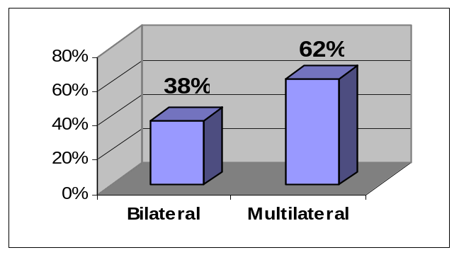
SOURCE-WISE COMMITMENTS:
- Commitments from multilateral sources were higher than that of the bilateral sources. Multilateral sources committed an amount of $2,157 million while commitments from bilateral sources were $1,310 million during the fiscal year 2007-08;
  - Commitments of $1,310 million from the bilateral sources consisted of $490 million grants and $820 million loans;
  - In the bilateral group, Japan with commitments of $467 million was the largest contributor, followed by China [$328 mill] and Saudia Arabia [$300 mill];
  - Commitments of $2,157 million from the multilateral sources consisted of $2 million grants and $2,155 million loans;
  - In the multilateral group, ADB with commitments of $1,437 million was the largest contributor, followed by IDB [$480 mill] and World Bank [$234 mill].
  - Source and Donor-Wise commitments are shown in Table-I:

Table I : SOURCE & DONOR-WISE COMMITMENTS
[ $ Million]
Financing Source | Donor | Grant | Loan | Grand Total
BILATERAL | CHINA | 0.4 | 327.7 | 328.1
BILATERAL | ITALY |  | 11.4 | 11.4
BILATERAL | JAPAN | 6.7 | 460.3 | 467.1
BILATERAL | KOREA |  | 20.0 | 20.0
BILATERAL | SAUDI ARABIA | 300.0 |  | 300.0
BILATERAL | U.K. | 136.9 |  | 136.9
BILATERAL | USA | 45.9 |  | 45.9
BILATERAL TOTAL |  | 489.9 | 819.5 | 1,309.4
MULTILATERAL | ADB |  | 1,436.8 | 1,436.8
MULTILATERAL | IBRD | 0.2 |  | 0.2
MULTILATERAL | IDA |  | 233.7 | 233.7
MULTILATERAL | IDB |  | 127.0 | 127.0
MULTILATERAL | IDB(ST) |  | 352.8 | 352.8
MULTILATERAL | OPEC FUND |  | 5.3 | 5.3
MULTILATERAL | U.N.H.C.R | 1.6 |  | 1.6
MULTILATERAL TOTAL |  | 1.8 | 2,155.6 | 2,157.4
Grand TOTAL |  | 491.7 | 2,975.1 | 3,466.8

PROJECT Vs NON-PROJECT COMMITMENTS:
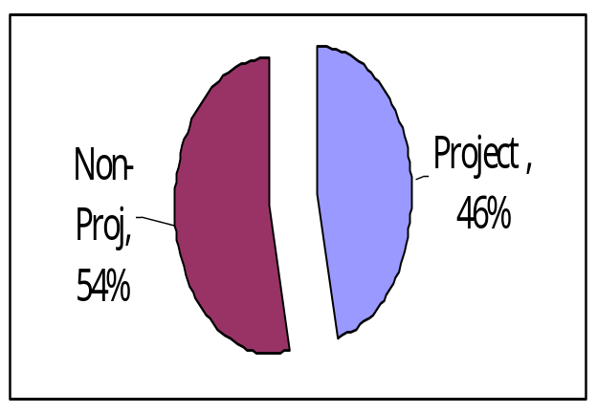
- Commitments for the Non-Project Aid were higher by $253 million than that for the Project Aid and amounted to $1,860 million and $1,607 million, respectively during the period under review. Bilateral sources contributed more for project aid compared to multilateral sources whose contribution was more for the non-project aid, especially for programme loans and earthquake assistance. Commitment of bilateral sources was $327 million and $982 million for non-project aid and project aid, respectively. Commitment of multilateral sources was $1,532 million and $625 million for non-project aid and project aid, respectively.

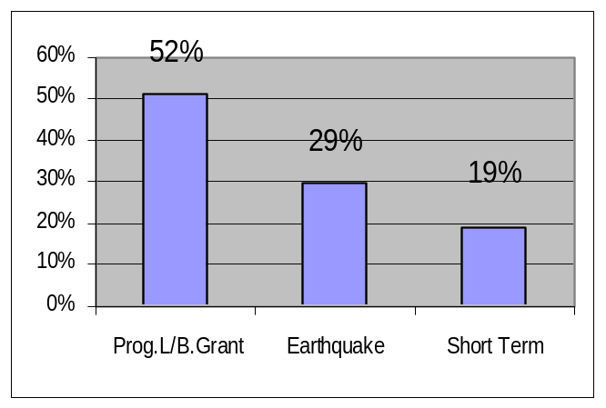
  - In the Non-Project aid, highest commitments of $957 million were for “Programme Loans/Budgetary Grants”, followed by Earthquake [$548 million], IDB [Short-term Cr.] $ 353 million and Afghan Refugees [$2 million].
  - Commitments for the Programme Loans amounted to $650 million and Budgetary Grants $307 million.
  - Commitments for earthquake amounted to $548 million.
  - Table-II summarizes the source & kind-wise position of commitments made during the period under review.
Table II: SOURCE & KIND – WISE COMMITMENTS
[ $ Million]
Financing Source | Donor | Afghan  R.R.A. | BOP/  CASH | Earthquake R.A. | IDB  (S.T) | Project | Grand  Total
Bilateral | CHINA | 0.4 |  |  |  | 327.7 | 328.1
Bilateral | JAPAN |  | 6.7 |  |  | 460.3 | 467.1
Bilateral | KOREA |  |  | 20.0 |  |  | 20.0
Bilateral | SAUDI ARABIA |  | 300.0 |  |  |  | 300.0
Bilateral | U.K. |  |  |  |  | 136.9 | 136.9
Bilateral | USA |  |  |  |  | 45.9 | 45.9
Bilateral | ITALY |  |  |  |  | 11.4 | 11.4
BILATERAL Total |  | 0.4 | 306.7 | 20.0 |  | 982.3 | 1,309.4
Multilateral | ADB |  | 650.0 | 401.2 |  | 385.6 | 1,436.8
Multilateral | IBRD |  |  |  |  | 0.2 | 0.2
Multilateral | IDA |  |  |  |  | 233.7 | 233.7
Multilateral | IDB |  |  | 127.0 |  |  | 127.0
Multilateral | IDB(ST) |  |  |  | 352.8 |  | 352.8
Multilateral | OPEC FUND |  |  |  |  | 5.3 | 5.3
Multilateral | U.N.H.C.R | 1.6 |  |  |  |  | 1.6
MULTILATERAL Total |  | 1.6 | 650.0 | 528.2 | 352.8 | 624.8 | 2,157.4
Grand Total |  | 2.0 | 956.7 | 548.2 | 352.8 | 1,607.0 | 3,466.8

SECTOR-WISE COMMITMENTS:
- Project Aid commitments of $1,607 million were made in 9 different Sectors. Sectors having over $100 million commitments were Power, Transport & Communications, water, health and rural development. Table-III shows sector–wise commitments of project aid during the period under review:
Table III : SECTOR – WISE COMMITMENTS
SECTOR | GRANT | LOAN | TOTAL
EDUCATION & TRAINING |  | 5.25 | 5.25
GOVERNANCE, RESEARCH & STATISTICS |  | 8.98 | 8.98
HEALTH & NUTRITION | 137.09 |  | 137.09
INDUSTRY & PRODUCTION |  | 11.40 | 11.40
POWER |  | 452.87 | 452.87
RURAL DEVELOPMENT & POVERTY REDUCTION | 45.93 | 77.90 | 123.83
SOCIAL WELFARE |  | 38.45 | 38.45
TRANSPORT & COMMUNICATION |  | 564.12 | 564.12
WATER |  | 265.05 | 265.05
TOTAL | 183.02 | 1,424.03 | 1,607.05

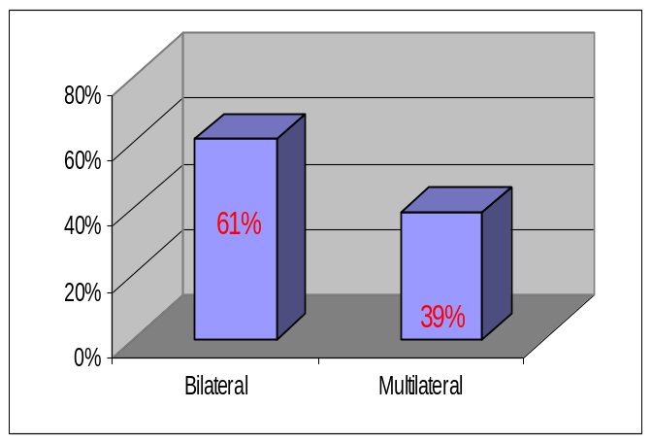
- Project Aid commitments from bilateral sources were higher by $357 million than that of the multilateral sources and amounted to $982 million and $625 million, respectively;
  - In the bilateral group, highest commitment of $460 million was from Japan, followed by China [$328 mill] and UK [$137 mill];
  - In the multilateral group, highest commitment of $386 million was from ADB, followed by IDA [$234 mill] and OPEC [$5 million];
  - Table-IV shows source-wise commitments made for the project aid during the fiscal year 2007-08:
Table IV : SOURCE & DONOR – WISE COMMITMENTS OF PROJECT AID
[$ Million]
Financing Source | Donor | Grant | Loan | Total
BILATERAL | CHINA |  | 327.7 | 327.7
BILATERAL | JAPAN |  | 460.3 | 460.3
BILATERAL | U.K. | 136.9 |  | 136.9
BILATERAL | USA | 45.9 |  | 45.9
BILATERAL | ITALY |  | 11.4 | 11.4
BILATERAL Total |  | 182.8 | 799.5 | 982.3
MULTILATERAL | ADB |  | 385.6 | 385.6
MULTILATERAL | IBRD | 0.2 |  | 0.2
MULTILATERAL | IDA |  | 233.7 | 233.7
MULTILATERAL | OPEC FUND |  | 5.3 | 5.3
MULTILATERAL Total |  | 0.2 | 624.5 | 624.8
Grand Total |  | 183.0 | 1,424.0 | 1,607.0
- Donor and project-wise details of commitments during 2007-08 are at Annex-A.

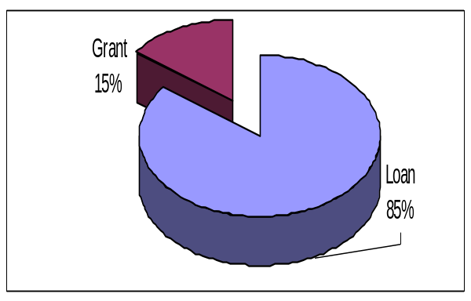
DISBURSEMENTS:
- Total disbursements of foreign economic assistance, including Earthquake, Afghan Refugees Relief Assistance and IDB [short-term credits], amounted to $3,581 million during July-June, 2007-08, comprising $527 million grants and $3,054 million loans, respectively.

SOURCE-WISE DISBURSEMENTS:
- Disbursements from multilateral sources were higher by $2,109 million than that from the bilateral sources;
  - Share of multilateral and bilateral sources was 79% and 21% of the total disbursements, respectively;
  - Disbursements from the bilateral sources were 68% grants and 32% loans;
  - Disbursements from the multilateral sources were dominated by loans which were about 99%;
  - Saudi arabia [$380 mill], UK [$108 mill], China [$100 mill] and USA [$79 mill] were the largest contributor in the bilateral group;
  - ADB [$1,791 mill], IDB [$705 mill] and World Bank [$316 mill] were the largest contributors in the multilateral group.
  - Table-V shows source and donor-wise disbursement during 2007-08:
Table V : SOURCE & DONOR – WISE DISBURSEMENTS
[$ Million]
Financing Source | Donor | Grant | Loan | TOTAL
BILATERAL | SAUDI ARABIA | 300.00 | 79.73 | 379.73
BILATERAL | U.K. | 108.22 |  | 108.22
BILATERAL | CHINA | 0.40 | 99.78 | 100.18
BILATERAL | U.S.A | 78.54 |  | 78.54
BILATERAL | FRANCE |  | 23.57 | 23.57
BILATERAL | JAPAN |  | 19.97 | 19.97
BILATERAL | GERMANY | 6.70 | 8.46 | 15.16
BILATERAL | CANADA | 6.51 |  | 6.51
BILATERAL | KUWAIT |  | 1.78 | 1.78
BILATERAL | SWITZERLAND | 1.63 |  | 1.63
BILATERAL | NORWAY | 0.58 |  | 0.58
BILATERAL | AUSTRALIA | 0.06 |  | 0.06
BILATERAL TOTAL |  | 502.64 | 233.28 | 735.92
MULTILATERAL | ADB | 2.20 | 1,788.68 | 1,790.87
MULTILATERAL | IDB(ST) |  | 699.76 | 699.76
MULTILATERAL | IDA | 4.35 | 261.58 | 265.92
MULTILATERAL | IBRD | 1.23 | 48.37 | 49.60
MULTILATERAL | EU | 13.06 |  | 13.06
MULTILATERAL | IFAD |  | 9.49 | 9.49
MULTILATERAL | OPEC FUND |  | 7.58 | 7.58
MULTILATERAL | IDB |  | 5.27 | 5.27
MULTILATERAL | U.N.H.C.R | 1.58 |  | 1.58
MULTILATERAL | U.N.D.P | 1.44 |  | 1.44
MULTILATERAL TOTAL |  | 23.87 | 2,820.72 | 2,844.59
Grand Total |  | 526.51 | 3,054.00 | 3,580.51

PROJECT Vs NON-PROJECT DISBURSEMENTS:
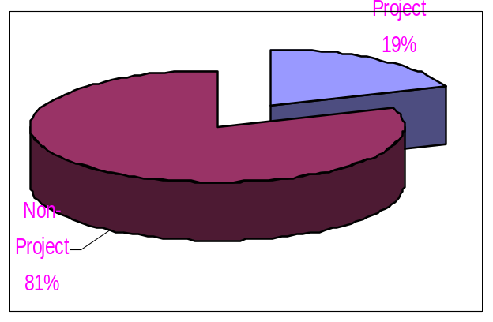
- Disbursements of Non-Project Aid were higher by $2,187 million than that of the Project Aid. Disbursement of non-project aid and project aid was $2,884 million and $697 million, respectively.
  - In the non-project aid, highest disbursements were for Programme Loans & Budgetary Grants, followed by Earthquake and IDB short-term credits.
  - Disbursements for programme loans and budgetary grants amounted to $1,104 million and $409 million, respectively.
  - A summarized position of disbursements is shown in the table-VI:
Table VI : PURPOSE – WISE DISBURSEMENTS
[$ Million]
Purpose | Grant | Loan | Grand Total
AFGHAN R.R.A. | 2.0 |  | 2.0
EARTHQUAKE R.A. | 4.8 | 863.9 | 868.7
BOP/CASH | 408.8 | 1,103.8 | 1,512.7
PROJECT | 110.9 | 586.5 | 697.4
Short Term Cr. |  | 499.8 | 499.8
Grand Total | 526.5 | 3,054.0 | 3,580.5

SECTOR-WISE DISBURSEMENTS:
- Project aid disbursements of $697 million were made in 12 different Sectors. Sectors claiming more than $50 million were Transport & Communication, Power and Rural Development. Table-VII shows sector wise disbursement of the project aid:

Table VII : SECTOR – WISE DISBURSEMENTS OF PROJECT AID
[$ Million]
SECTOR | GRANT | LOAN | TOTAL
AGRICULTURE | 0.91 | 27.22 | 28.13
EDUCATION & TRAINING | 11.28 | 11.84 | 23.13
ENVIRONMENT | 2.26 | 14.72 | 16.98
HEALTH & NUTRITION | 16.56 | 30.02 | 46.58
INDUSTRY & PRODUCTION | 0.18 | 0.78 | 0.96
MANPOWER, EMPLOYMENT & HRD | 0.15 |  | 0.15
POPULATION WELFARE | 15.62 |  | 15.62
POWER | 1.57 | 114.12 | 115.69
RURAL DEVELOPMENT & POVERTY REDUCTION | 46.24 | 41.65 | 87.89
SOCIAL WELFARE | 0.25 | 19.44 | 19.69
TRANSPORT & COMMUNICATION |  | 221.94 | 221.94
WATER |  | 37.59 | 37.59
TOTAL | 110.93 | 586.51 | 97.44

B: AID OUTFLOW:

Debt Servicing
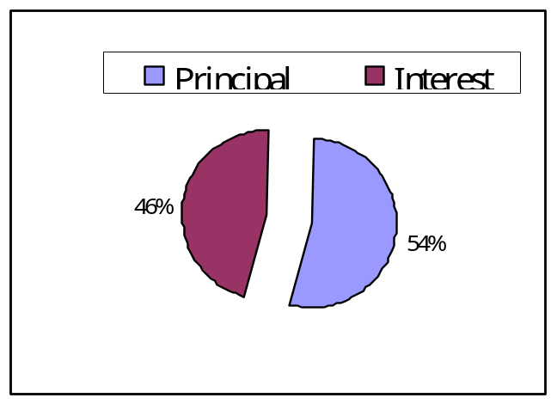
- EAD is responsible for making timely debt-servicing of foreign loans. Actual debt servicing of foreign loans amounted to $2,079 million, comprising $2,000 million central loans and $79 million guaranteed loans. Principal repayment amounted to $1,130 million and interest payments were $949 million during 2007-08. About 31% [$639 million] of the total debt-servicing went to the bilateral creditors and 66% [$1,367 million] to the multilateral creditors. About 96.5% [$2,006 million] was against the medium & long-term loans while 3.5% [$73 million] was against the short-term loans. A summarized view of debt-servicing is shown in the following Table.

Table VIIII: Debt Servicing During 2007-08
[$ Million]
Particulars |  | Principal | Interest | Total
A | Medium & Long-Term
A | Bilateral | 258.261 | 380.261 | 638.522
A | Multilateral | 830.329 | 536.987 | 1367.316
Total: A |  | 1088.59 | 917.248 | 2005.838
B | Short-Term | 41.28 | 31.971 | 73.251
Grand Total: [A+B] |  | 1,129.87 | 949.22 | 2079.089

Recovery of Relent loans:
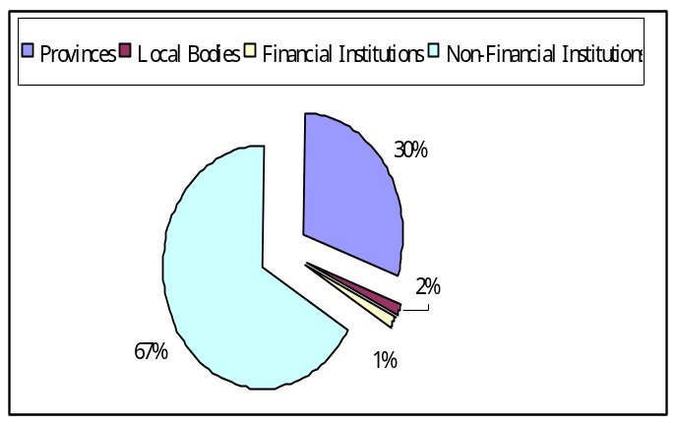
- Foreign loans are relent to the Provinces, Local Bodies and Development Financial Institutions. Recovery of the relent loans and exchange risk fee is the responsibility of the EAD and is carried out in the light of standard relending terms, approved by the ECC. During 2007-08, recoveries of foreign relent loans amounted to Rs.49.4 billion, comprising Rs.28.3 billion principal and Rs.21.1 billion interest and exchange risk fee. The amount was recovered from the provinces [Rs.14.9 bill], Local Bodies [Rs.0.9 bill], Financial Institutions [Rs.0.7 bill] and Non-Financial Institutions [Rs.32.9 billion].

Guarantee Fee
- Under the standard re-lending terms, guarantee fee @ 0.5% p.a. is chargeable from the borrowers on the debt disbursed and outstanding from time to time against the loans guaranteed by the Federal Government. An amount of Rs.74.9 million was recovered as guarantee fee during the period July-June 2007-08. Highest Fee was paid by the by the Sandek Metals followed by Sui Northern and PARCO. Agency-wise amount recovered is shown in the following table.

Table IX: Recovery of Guarantee Fee during 2007-08
[Rs. Million]
Agency | Amount
Sandek Metals Lted. | 40.925
SNGPL | 17.903
PARCO | 16.025
Total | 74.853

Debt Rescheduling
- As per Paris Club-III, Agreed Minutes total amount of US$ 12.8 billion has been rescheduled out of which the Official Development Assistance (ODA) debt consists of US$ 8.8 billion and Non-Official Development Assistance (Non-ODA) debt of US$ 3.9 billion have been rescheduled. ODA debt is owed directly by the Governments or their public sector agencies while the non-ODA debt is advanced by financial institutions, suppliers/exporters and their private sector and is guaranteed either directly by their Governments or their appropriate institutions. ODA rescheduled debt is repayable over a period of 38 years including 15 years of grace, starting from May 31, 2017 and ending on November 30, 2039 and carries an interest rate as favourable as per under the original contracts whereas non-ODA rescheduled debt is repayable over a period of 23 years including 5 years of grace at an appropriate market rate, starting from May 31, 2007 and ending on November 30, 2024.

C: External Debt and Liabilities
- Debt stock or disbursed and outstanding debt [DOD] is the total principal outstanding that a borrower owes to creditors. DOD is at a point of time and therefore a stock concept which contrasts to flows like disbursement, debt-servicing [principal repayment and interest payment] that are during a period. It is the total loan amount that has been borrowed and is yet to be returned to the creditors and is arrived at by aggregating disbursements and deducting principal repayments. At times, this simple arithmetic may differ due to Valuation adjustments which explain differences between the change in debt outstanding and the net movements.
- DOD is not an immediate claim and therefore does not affect the borrower directly. It does not include interest on the outstanding amount and is not total claim either. It is the principal amount due that has to be repaid over time as per the schedule of payment. The concept of DOD is useful for assessing external debt burden of a country. It is used for inter-country and inter-temporal comparisons. The absolute level of debt doesn’t provide correct picture of indebtedness and has to be linked to macroeconomic variables like GDP to find the extent of debt burden.
- Debt stock impinges on the economy through the problem of debt overhang. If external debt burden is high, potential investors are discouraged from investing because of the fear that debt service would make the first claim on the state’s revenue and foreign exchange reserves and the return on investments may not be realized.
- The Outstanding Stock of External Debt & Liabilities (EDL) increased from $40.48 billion as on June 30, 2007 to $46.29 billion as on June 30, 2008 depicting an increase of 14.34% over the stock of June 30, 2007 (Annex-C). The total EDL stock consists of Government External Debt (GED), Private Sector Debt (PSD), Central Bank Debt (CBD) and External Liabilities with their respective share $40.24 billion, $2.8 billion, $1.94 billion and $217 million respectively as on June 30, 2008. The GED was 87 percent of total EDL.
Government External Debt (GED)
- GED increased from $35.35 billion to $40.24 billion (Annex-B), witnessing 13.85 percent increase ($4.9 billion) during same period which resulted due to increase of the outstanding stocks of multilateral ($2.89 billion) and bilateral creditors ($1.4 billion). In the Multilateral creditors, the stock of ADB increased by $2.26 billion, followed by IDA by $735 million and IDB Short Term Credit by $688 million. In the Bilateral creditors, the major increase of $672 million pertained to Japanese stock, followed by France $345 million and Germany $299 million.
- The change in outstanding stock of the external debt can be incurred by new disbursements, repayment of principal and exchange rate fluctuation (known as Translation exchange rate loss/gain) of the reporting currency.
- During 2007-08, total disbursement of foreign loans was $3.05 billion and repayment of principal was $1.27 billion. The net impact of these two factors increased the stock of PPG debt by $1.79 billion. The remaining addition of $3.11 billion (Annex-C) in the total increase of $4.9 billion stock was due to depreciation of US dollar against JPY, Euro and SDR.
- During July-June 2007-08, US dollar depreciated by 14.46 percent, 12.01 percent and 6.92 percent against Euro, JPY and SDR respectively as indicated in the following table:
Table X: Dollar Depreciation vis-à-vis Major Currencies during 2007-08
Currency | Exchange rate (currency/US $)  as on |  | Depreciation %
Currency | 30-06-2007 | 30-06-2008 | Depreciation %
Yen | 122.48 | 107.77 | 12.01
Euro | 0.78 | 0.64 | 14.46
SDR | 0.66 | 0.61 | 6.92

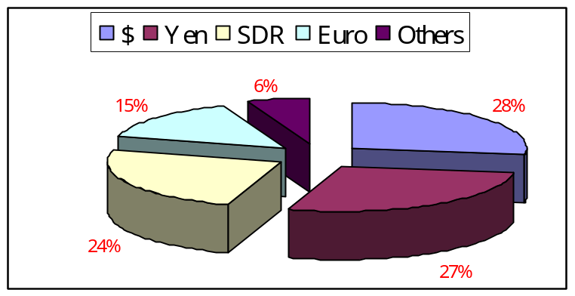
- The GED stock is composed of four major currencies i.e USD, JPY, SDR and Euro. Highest portion pertains to US Dollar (US $ 11.07 billion) followed by JPY (Equivalent US $ 11.06 billion), SDR (Equivalent US $ 9.76 billion), Euro (Equivalent US $ 6.04 billion) and all other currencies (Equivalent US $ 2.31 billion).

Debt Limitation and Fiscal Responsibility Act
- The Law provides for elimination of revenue deficit and reduction of public debt to a prudent level by effective debt management and matters connected therewith and lays down the following principles of sound fiscal and debt management:
  - Reducing the revenue deficit to “Nil” no later than the 30th June 2008, and thereafter maintaining a revenue surplus;
  - Ensuring that within a period of ten financial years, beginning from the 1st July, 2003 and ending on the 30th June, 2013, the total public debt at the end of the tenth financial year does not exceed sixty percent of the estimated gross domestic product for that year and thereafter maintaining the total public debt below sixty per cent of gross domestic product for any given year;
  - Ensuring that in every financial year, beginning from the 1st July 2003, and ending on the 30th June 2013, the total public debt is reduced by not less than two and a half per cent of the estimated gross domestic product for any given year:
  - Not issuing new guarantees, including those for rupee lending, bonds, rates of return, output purchase agreements and all other claims and commitments that may be prescribed, from time to time, for any amount exceeding two per cent of the estimated gross domestic product in any financial year.
  - “Establishment of the Debt Policy Co-ordination Office” which shall take appropriate measures for effective debt management and matters connected therewith and to ensure greater transparency in its fiscal operation.

ANNEX - A
COMMITMENTS OF FOREIGN AID DURING JULY-JUNE 2007-08
[Fig. in Million]
Donor | Type of Aid | Project No. | Name of Project / Programme | Date of |  | Base Currency [BC] | Amount Committed in
 |  |  |  | Signing | Closing | Base Currency [BC] | BC | $
ADB | Loan | 2286-PAK | RENEWABLE ENER. DEV. SEC. INV. | 05.10.2007 | 30.06.2012 | JPY | 12508.7 | 107.6
ADB | Loan | 2287-PAK(SF) | RENEWABLE ENER. DEV. INV. PROG | 05.10.2007 | 30.06.2012 | SDR | 6.8 | 10.6
ADB | Loan | 2310-PAK(SF) | SINDH COASTAL COMMY. DEV. PROJ | 07.12.2007 | 30.06.2013 | SDR | 24.2 | 38.5
ADB | Loan | 2335-PAK(SF) | DISPLACED PEOPLE LIVELIHOOD EQ | 04.07.2007 | 31.12.2008 | SDR | 263.9 | 401.2
ADB | Loan | 2340-PAK | 2ND GENE. OF CAPITAL MRK PROM | 15.05.2008 | 30.06.2009 | USD | 400.0 | 400.0
ADB | Loan | 2385-PAK | PUNJAB GOVT.EFFICIENY IMP.SP-I | 14.12.2007 | 31.01.2008 | USD | 250.0 | 250.0
ADB | Loan | 2386-PAK(SF) | TA PUNJAB GOVT. EFFICIENCY IMP | 14.12.2007 | 31.12.2012 | SDR | 5.7 | 9.0
ADB | Loan | 2396-PAK | POWER TRANS. ENHANCEMENT PROG. | 20.05.2008 | 31.12.2013 | USD | 220.0 | 220.0
CHINA | Grant | CHINA-AFGHAN07 | REPATRIATION OF AFGHAN REFUGEE | 17.07.2007 | 17.07.2007 | USD | 0.4 | 0.4
CHINA | Loan | 320080001 | KARAKORAM HIGHWAY IMPROV. PROJ | 18.01.2008 | 31.12.2009 | USD | 327.7 | 327.7
IBRD | Grant | TF-90919 | INST DEV OF PAK PHILANTHROPY | 29.10.2007 | 29.10.2010 | USD | 0.2 | 0.2
IDA | Loan | 3834-3-PAK | II POVERTY ALLEVIATION FUND | 07.12.2007 | 30.06.2010 | SDR | 32.5 | 51.6
IDA | Loan | 3834-4-PAK | II POVERTY ALLEVIATION FUND | 07.12.2007 | 30.06.2010 | SDR | 16.6 | 26.3
IDA | Loan | 4358-PAK | SINDH WATER SEC IMPR PROJ PH.I | 05.10.2007 | 30.04.2013 | SDR | 100.1 | 155.8
IDB | Loan | PAK-114 | ISTISNA'A FINANCING AGREEMENT | 03.01.2008 | 31.12.2009 | USD | 127.0 | 127.0
IDB(ST) | Loan | CM2007 | COMMODITY MURABAHA 2007 | 14.12.2007 | 31.12.2007 | USD | 156.0 | 156.0
IDB(ST) | Loan | CM2007(EUR) | COMMODITY MURABAHA 2007 (EUR) | 14.12.2007 | 31.12.2007 | EUR | 100.0 | 146.8
IDB(ST) | Loan | PAK-ITFO-187 | IMPORT OF CRUDE OIL (PARCO) | 15.06.2008 | 15.07.2008 | USD | 25.0 | 25.0
IDB(ST) | Loan | PAK-ITFO-188 | IMPORT OF CRUDE OIL (PARCO) | 15.06.2008 | 15.07.2008 | USD | 25.0 | 25.0
ITALY | Loan | ITAL-2008 | SME PROMOTION IN PAKISTAN | 02.06.2008 | 02.06.2010 | EUR | 7.8 | 11.4
JAPAN | Grant | 10468 | NON PROJECT GRANT AID | 28.01.2008 | 28.04.2008 | JPY | 700.0 | 6.7
JAPAN | Loan | PK-P57 | EAST-WAST IMPROV. PROJ(N70) | 03.05.2008 | 31.05.2017 | JPY | 15492.0 | 148.8
JAPAN | Loan | PK-P58 | PUNJAB TRANS. LINES AND GRID | 03.05.2008 | 30.06.2015 | JPY | 11943.0 | 114.7
JAPAN | Loan | PK-P-59 | PUNJAB IRRIG. SYSTEM IMPRO. PR | 03.05.2008 | 30.06.2017 | JPY | 11382.0 | 109.3
JAPAN | Loan | PK-P60 | RURAL ROAD CONS PROJ (II) SIND | 03.05.2008 | 30.06.2015 | JPY | 9126.0 | 87.6
KOREA | Loan | PAK-3 | INFR. RECON. & REH. PROJ. AJK | 15.02.2008 | 31.12.2013 | USD | 20.0 | 20.0
OPEC FUND | Loan | 1134-P | INST. OF EMERGING TECH LHR PRO | 06.09.2007 | 31.12.2010 | USD | 5.3 | 5.3
SAUDI ARABIA | Grant | SA08 | SAUDI US$300 GRANT FOR GOP | 08.03.2008 | 08.03.2008 | USD | 300.0 | 300.0
U.K. | Grant | 10765 | MATERNAL NEWBORN & CHILD HEALT | 04.03.2008 | 28.02.2013 | GBP | 69.0 | 136.9
U.N.H.C.R | Grant | 11800-32 | AFGHAN REFUGEES, R.A. JUNE 09 | 30.06.2008 | 30.06.2008 | USD | 1.6 | 1.6
USA | Grant | 391-111-60 | LAW ENFORCEMENT, AREA DEVE.&D | 27.09.2007 | 30.09.2008 | USD | 20.4 | 20.4
USA | Grant | 391-111-61 | LAW ENFORCEMENT, AREA DEVELOP. | 28.09.2007 | 30.09.2008 | USD | 0.4 | 0.4
USA | Grant | 391-111-62 | LAW ENFOR. REFORMS & CAPACITY | 30.04.2008 | 30.09.2009 | USD | 3.2 | 3.2
USA | Grant | 391-111-63 | LAW ENFORCEMENT, AREA DEVE.&DR | 30.04.2008 | 30.09.2009 | USD | 17.0 | 17.0
USA | Grant | 391-111-64 | FATA ROADS PHASE-II L.E.A.D.&D | 30.04.2008 | 30.09.2009 | USD | 5.0 | 5.0

Annex-B
External Debt and Liabilities
($ Million)
Particulars | 30th June, 2008 | 30th June, 2007 | Increase/ (Decrease) | % Change
TOTAL EXTERNAL DEBT & LIABILITIES(I + II+III+IV) | 46,284 | 40,480 | 5,803 | 14.34%
TOTAL EXTERNAL DEBT (I + II+III) | 46,067 | 40,207 | 5,860 | 14.57%
I)Government Debt (A+B) | 40,243 | 35,348 | 4,895 | 13.85%
A. MEDIUM AND LONG TERM | 39,530 | 35,323 | 4,207 | 11.91%
i) MULTILATERAL | 21,583 | 18,687 | 2,896 | 15.50%
ADB | 9,408 | 7,151 | 2,257 | 31.56%
IBRD | 2,015 | 2,149 | (135) | -6.26%
IDA | 9,517 | 8,782 | 735 | 8.37%
Other | 643 | 604 | 38 | 6.36%
EIB | 72 | 72 | 1 | 0.98%
IDB | 345 | 315 | 31 | 9.69%
IFAD | 177 | 169 | 8 | 4.92%
NORD. DEV. FUND | 19 | 17 | 2 | 12.91%
NORD. I. BANK | 10 | 12 | (2) | -15.65%
OPEC FUND | 18 | 20 | (1) | -6.73%
ii) BILATERAL | 15,117 | 13,695 | 1,422 | 10.38%
a) Paris Club Countries | 13,927 | 12,694 | 1,233 | 9.71%
AUSTRIA | 84 | 75 | 10 | 13.21%
BELGIUM | 41 | 63 | (22) | -35.12%
CANADA | 538 | 514 | 23 | 4.48%
FINLAND | 6 | 6 | (0) | -0.85%
FRANCE | 2,507 | 2,162 | 345 | 15.98%
GERMANY | 2,142 | 1,843 | 299 | 16.23%
ITALY | 117 | 154 | (38) | -24.34%
JAPAN | 5,777 | 5,105 | 672 | 13.16%
KOREA | 515 | 575 | (60) | -10.46%
NETHERLANDS | 137 | 118 | 19 | 16.26%
NORWAY | 30 | 35 | (5) | -13.61%
RUSSIA | 125 | 127 | (3) | -2.24%
SPAIN | 81 | 81 | (1) | -1.07%
SWEDEN | 157 | 159 | (3) | -1.67%
SWITZERLAND | 116 | 94 | 22 | 22.96%
UNITED KINGDOM | 13 | 13 | (1) | -4.97%
UNITED STATES | 1,542 | 1,567 | (25) | -1.61%
b) Non Paris Club Countries | 1,190 | 1,001 | 189 | 18.83%
BAHRAIN | 12 | 12 | - | 0.00%
CHINA | 925 | 817 | 109 | 13.33%
KUWAIT | 85 | 85 | 0 | 0.46%
LIBYA | 5 | 6 | (1) | -10.52%
SAUDI ARABIA | 96 | 16 | 80 | 497.38%
UNITED ARAB EMIRATES | 66 | 66 | 0 | 0.26%
iii) NOTES & BONDS | 2,665 | 2,713 | (48) | -1.76%
Eurobond / Sukuk / Global Bonds | 2,650 | 2,650 | - | 0.00%
Saindak Coppor/Gold Project bonds | - | 5 | (5) | -100.00%
Local Currency Bonds(TBs & PIBs) | 15 | 58 | (43) | -74.28%
iv) COMMERCIAL BANKS | 124 | 145 | (21) | -14.57%
BAHRAIN | 124 | 145 | (21) | -14.57%
v) DEFENCE | 41 | 83 | (41) | -50.00%
CHINA | 41 | 83 | (41) | -50.00%
B. SHORT TERM DEBT | 713 | 25 | 688 | 2752.56%
IDB | 713 | 25 | 688 | 2752.56%
II) PRIVATE-SECTOR DEBT | 2,887 | 2,252 | 635 | 28.18%
A) MULTILATERAL CREDITORS | 322 | 280 | 42 | 15.07%
B) PARIS CLUB | 1,274 | 760 | 514 | 67.70%
C) NON-PARIS CLUB | 9 | 1 | 7 | 635.04%
D) PIA (Hire/Purchase (Long Term) (SBP) | 1,007 | 962 | 46 | 4.76%
E) BONDS | 275 | 250 | 25 | 10.00%
III) State Bank of Pakistan | 2,937 | 2,607 | 330 | 12.65%
DEPOSITS | 1,600 | 1,200 | 400 | 33.33%
IMF | 1,337 | 1,407 | (70) | -5.00%
IV) TOTAL LIABILITIES | 217 | 273 | (56) | -20.65%
Special USD Bond | 121 | 156 | (35) | -22.17%
Construction Company bonds (NHA) | 66 | 88 | (22) | -25.01%
SWAP | 30 | 30 | - | 0.00%

Annex-C
Translational Exchange Rate Loss
 | (Figures in Million)
Currency | Outstanding Balance | Ex. Rate 30.06.08 | Equivalent Us $ | Ex. Rate 30.06.07 | Equivalent Us $ | Difference
1 | 2 | 3 | 4=2/3 | 5 | 6=2/5 | 7=4-6
Australian Dollar | 17.93 | 1.04 | 17.21 | 1.19 | 15.09 | 2.12
Canadian Dollar | 664.78 | 1.01 | 660.36 | 1.07 | 623.74 | 36.62
Swiss Franc | 163.75 | 1.03 | 158.88 | 1.23 | 133.22 | 25.66
Chinese Won | 2,155.31 | 6.87 | 313.92 | 7.62 | 282.92 | 31.00
Danish Krone | 80.37 | 4.75 | 16.93 | 5.54 | 14.51 | 2.42
Euro | 3,843.09 | 0.64 | 6,039.08 | 0.74 | 5,165.69 | 873.39
Pound Sterling | 50.59 | 0.50 | 100.34 | 0.50 | 100.98 | -0.64
Islamic Dinar | 43.53 | 0.61 | 70.79 | 0.66 | 65.89 | 4.90
Japanese Yen | 1,191,595 | 107.77 | 11,056.33 | 122.48 | 9,728.90 | 1,327.43
Korean Won | 8,997.42 | 1,037.50 | 8.67 | 927.80 | 9.70 | -1.03
Kuwaiti Dinar | 22.54 | 0.27 | 85.07 | 0.29 | 78.24 | 6.83
Libyan Dinar | 5.50 | 1.19 | 4.62 | 1.27 | 4.33 | 0.29
Norwegian Krona | 148.50 | 5.06 | 29.34 | 5.97 | 24.86 | 4.48
Pak Rupee | 9.59 | 68.10 | 0.14 | 60.50 | 0.16 | -0.02
Pool Unit Value | 0.05 | 0.00 | 773.28 | 0.00 | 657.09 | 116.20
Saudi Riyal | 60.12 | 3.75 | 16.03 | 3.75 | 16.03 | 0.00
Special Drawing Right | 6,004.19 | 0.61 | 9,763.70 | 0.66 | 9,087.64 | 676.06
Swedish Kronor | 334.80 | 5.99 | 55.92 | 6.91 | 48.47 | 7.44
Singapore Dollar | 0.09 | 1.36 | 0.06 | 1.54 | 0.06 | 0.01
Thai Baht | 3.30 | 33.58 | 0.10 | 34.56 | 0.10 | 0.00
United States Dollar | 11,072.49 | 1.00 | 11,072.49 | 1.00 | 11,072.49 | 0.00
Total |  |  | 40,243.28 |  | 37,130.11 | 3,113.18

